**EXERCISE NO: 5**

**DATE: 15/10/2020**

**AIM:**

 To print missing characters to make string pangram.

**PROGRAM:**

a = input()

a = set(a.strip())

a.remove(chr(32))

b = "abcdefghijklmnopqrstuvwxyz"

b = set(b)

b = b.difference(a)

b = list(b)

b.sort()

print("".join(b))

**LINK:** <http://103.53.53.18/mod/vpl/forms/edit.php?id=235&userid=1695>

**OUTPUT:**

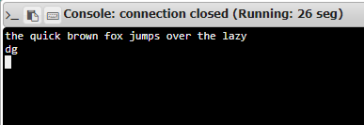

**RESULT:**

Hence the missing characters are printed to make string pangram.